SELECT * FROM product WHERE price <= 50000;

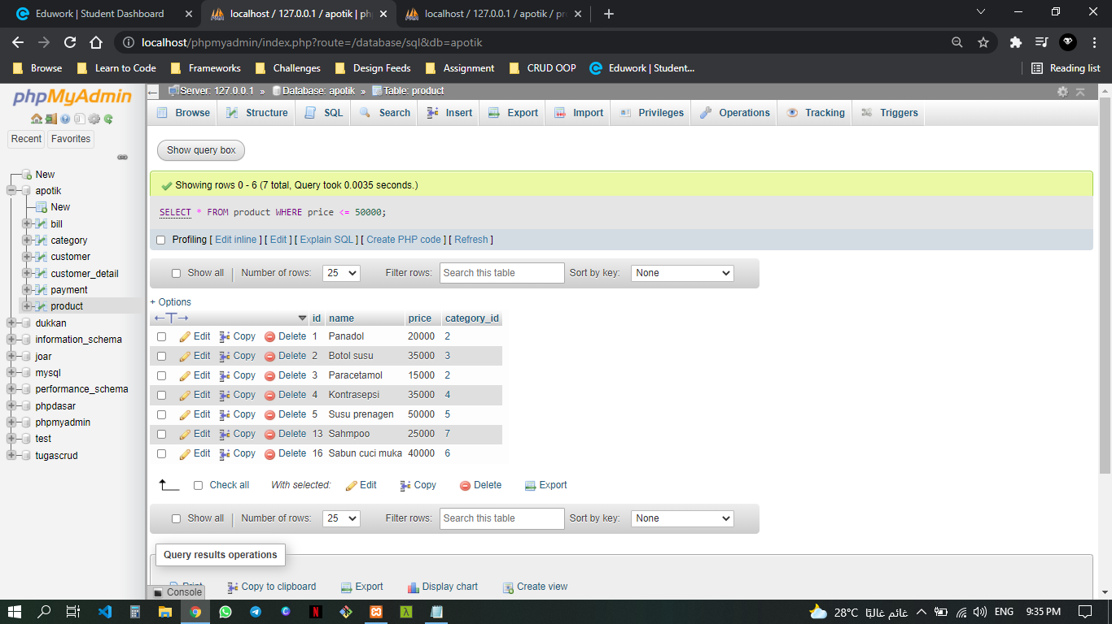

SELECT * FROM product WHERE category_id = 3;

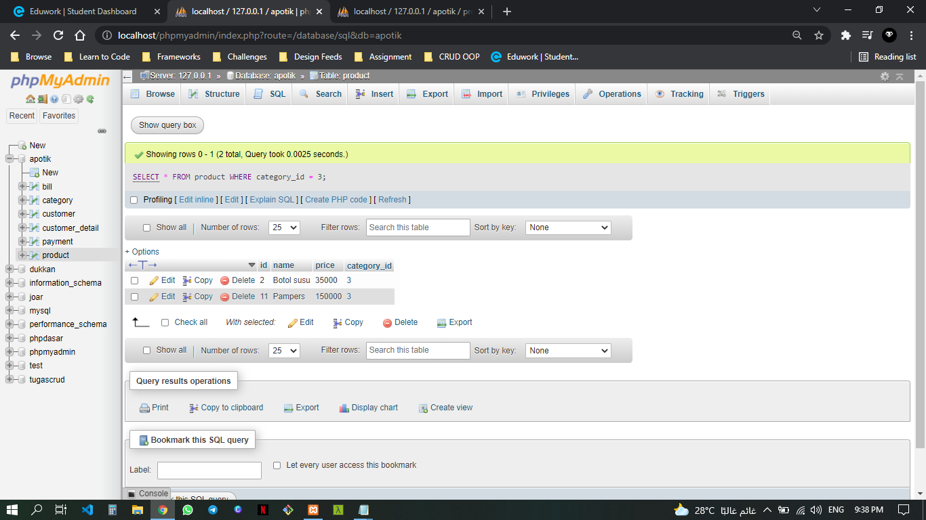

SELECT * FROM product WHERE price <= 50000 ORDER BY price ASC;

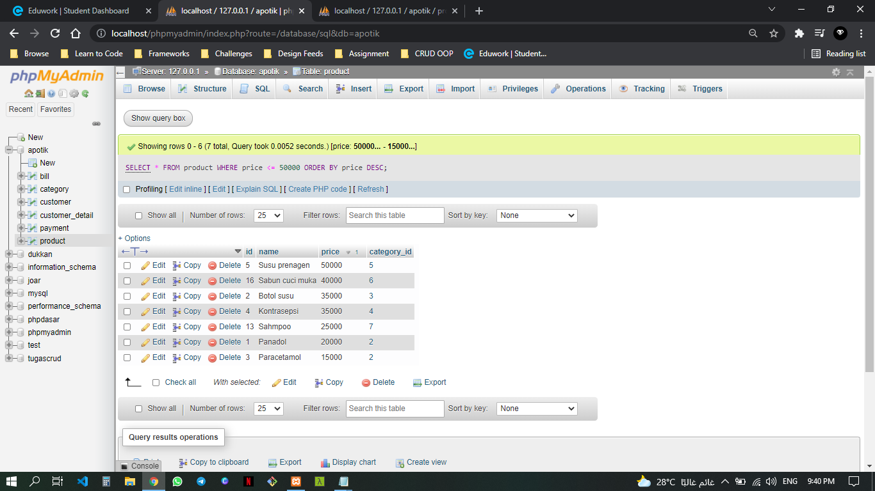

SELECT * FROM product WHERE price <= 50000 ORDER BY price DESC;

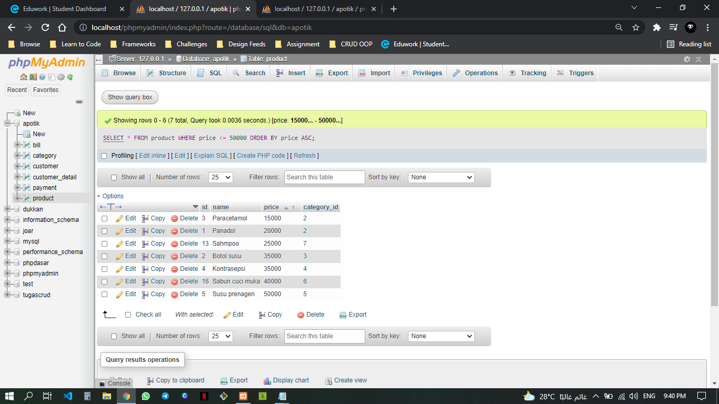

SELECT * FROM product WHERE name LIKE "%ol%";

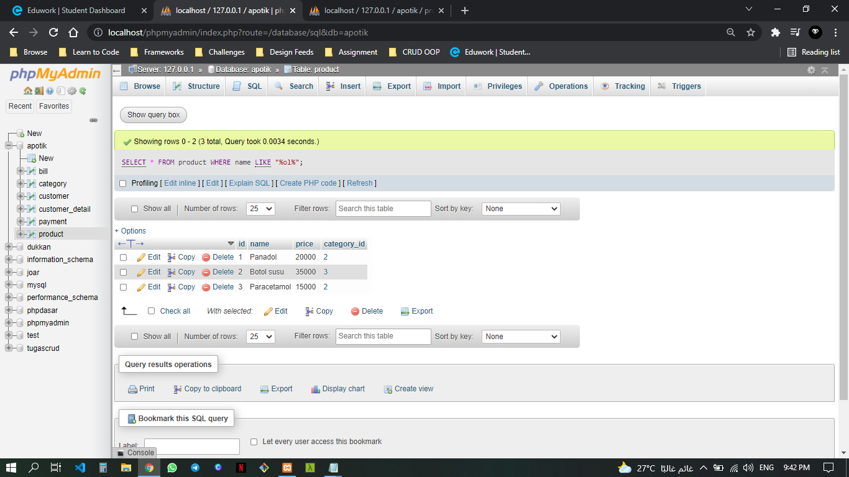

*SELECT* name*, MAX(*price*) AS* price *FROM* product*;*

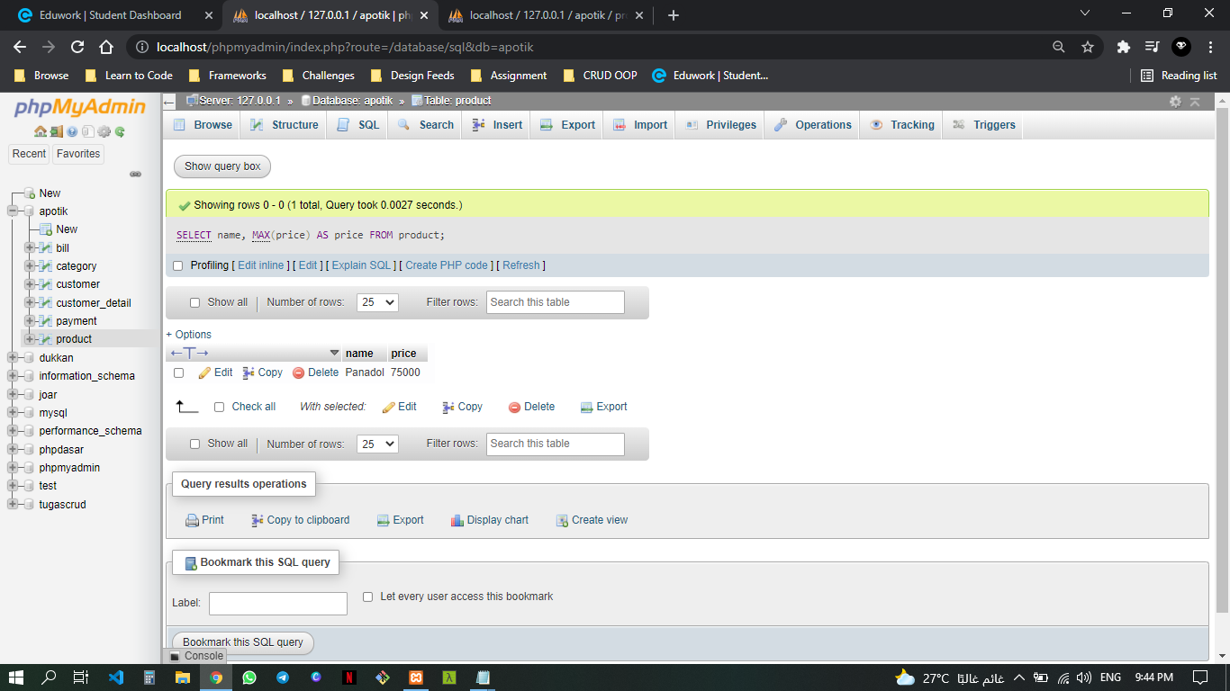

*SELECT COUNT(*id*) FROM* product*;*

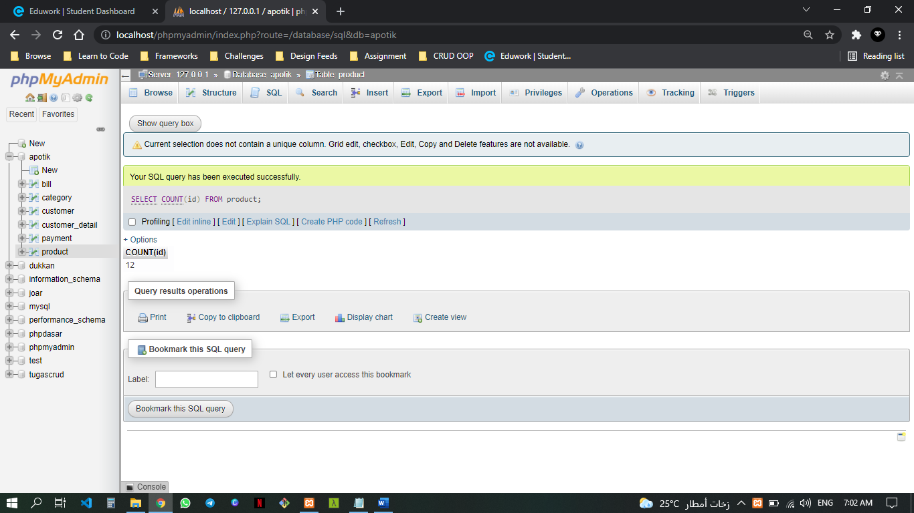

*SELECT* category_id*, SUM(*price*) as* total *FROM* product *GROUP BY* category_id*;*

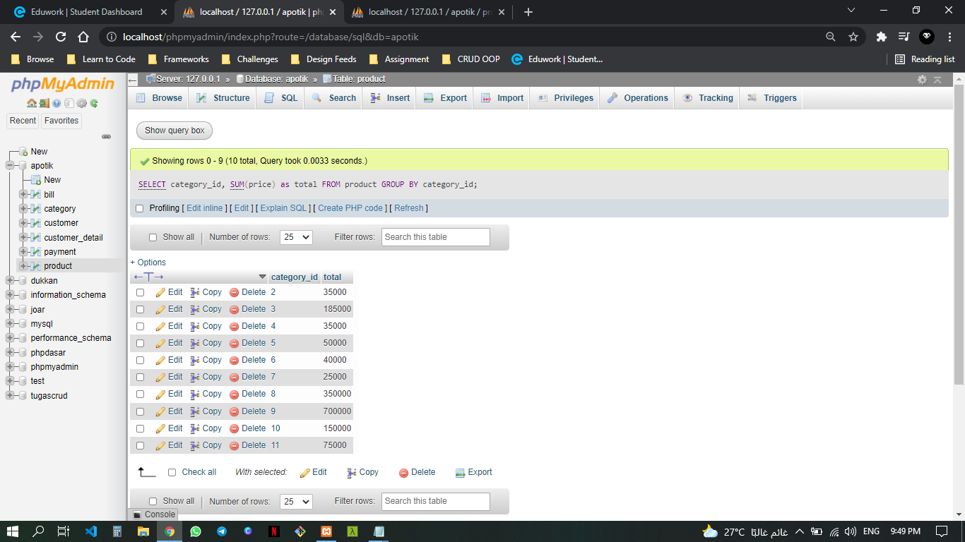

*SELECT* category_id*, SUM(*price*) as* total *FROM* product *WHERE* price *<=* 50000 *GROUP BY* category_id*;*

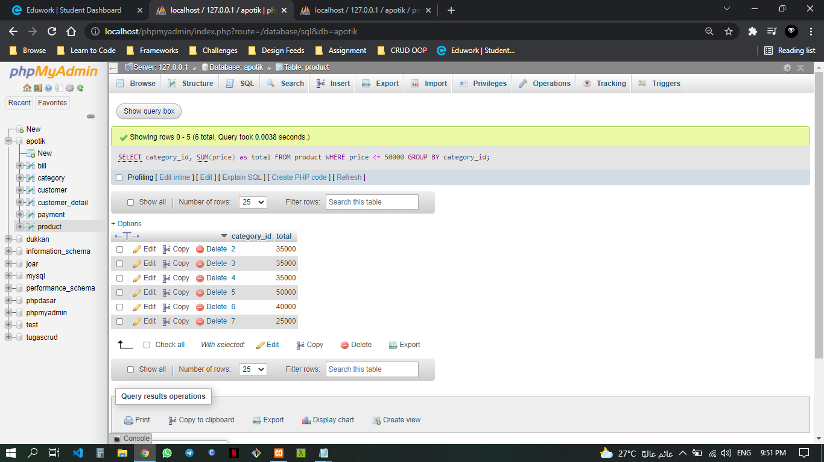

*SELECT* category_id*, SUM(*price*) as* total *FROM* product *WHERE* price *<=* 50000 *GROUP BY* category_id *ORDER BY* price *ASC;*

